



INTERNSHIP
IN
Artificial Intelligence
CONDUCTED BY
Active Galaxy
Kamaraj Nagar, Tambaram

Abstract

This internship report presents the outcomes of a six-month industrial training program completed by Logesh B at Active Galaxy Group of Companies, Chennai, focusing on the development of an artificial intelligence-based system titled “Public Human Assault Prediction using AI.” The core objective of the project was to design and implement a proactive, intelligent surveillance tool capable of detecting potentially aggressive or violent human behavior in public spaces before an actual incident occurs. The aim was to leverage AI technologies to enhance public safety and support law enforcement through early warnings.

The project was driven by the increasing global demand for smart city infrastructure and intelligent threat detection systems. As urban areas become more densely populated, traditional surveillance methods fall short in identifying and responding to subtle behavioral cues that might precede acts of violence. This project attempted to bridge that gap using machine learning (ML) and deep learning (DL) techniques applied to behavioral and contextual data.

The end-to-end pipeline involved the entire data science lifecycle: data collection, preprocessing, exploratory data analysis (EDA), model training, evaluation, and deployment. Data used for training was either simulated or anonymized to ensure compliance with ethical standards and privacy regulations. The technologies employed include Python for scripting, Pandas and NumPy for data handling, Matplotlib and Seaborn for visualization, and libraries such as Scikit-learn and TensorFlow/Keras for machine learning model development.

Various classification models including logistic regression, decision trees, and artificial neural networks were trained and tested. Their performance was evaluated using standard metrics such as accuracy, precision, recall, and F1-score. The best-performing model was wrapped into a Flask API, which served predictions to a lightweight HTML-based user interface for real-time usage.

One of the distinguishing aspects of this project was its ethical consideration. Surveillance data inherently raises concerns around privacy, bias, and responsible AI usage. The internship included guidelines and mentorship on how to mitigate these risks by incorporating fairness, transparency, and accountability in both model development and system design.

The final outcome was a functional proof-of-concept capable of classifying human behavior patterns and alerting users to possible threats in real-time. Though developed in a simulated environment, the system lays the groundwork for integration into smart surveillance systems and Internet of Things (IoT) networks used in public areas like transport hubs, stadiums, and commercial zones.

This internship offered a holistic learning experience, blending technical implementation with ethical practice, and significantly contributed to my understanding of how artificial intelligence can be applied to solve real-world safety challenges.

Table of Contents
Title Page
- Abstract
- Briefing about the industry
- Introduction to Technology and Domain
- Weekly Work Done
- Flowcharts
- Sample Outputs
- Internship Offer Letter
- Internship Certificate
- Outcome of The Training

Briefing About the Industry

Active Galaxy Group of Companies is a multifaceted, innovation-driven technology conglomerate headquartered in Chennai, India. The organization operates through a diversified portfolio that includes Active Galaxy, Mayon Infotech, the International Journal for Advanced Data Science & Technology (IJADST), and the AG Welfare Association. These branches work synergistically to drive advancements in Artificial Intelligence (AI), Machine Learning (ML)
With a mission to bridge the gap between theoretical learning and industrial application, Active Galaxy has carved a unique space in the technology ecosystem by offering real-time solutions to complex problems faced by modern urban societies. The company specializes in AI-powered surveillance systems, smart automation, predictive analytics, and intelligent decision-support tools, particularly in the areas of public safety, healthcare, education, and urban governance.
The company’s culture is deeply rooted in responsible AI, advocating for practices that promote transparency, fairness, and data privacy. It consistently encourages interns to explore innovative solutions while remaining conscious of ethical implications—particularly in sensitive domains like public surveillance and behavioral analytics.
In the context of this internship, Active Galaxy identified a growing societal need for AI-driven predictive systems capable of enhancing public safety in high-density areas such as train stations, markets, and public gatherings. By initiating the project titled “Public Human Assault Prediction using AI,” the organization aimed to contribute toward smart-city safety infrastructure through real-time behavioral monitoring and threat assessment.
Through its robust mentorship programs, interdisciplinary projects, and commitment to social impact, Active Galaxy Group of Companies continues to play a vital role in shaping the future of applied AI in India.

Introduction to Technology And Domain

The internship project titled “Public Human Assault Prediction using AI” is positioned at the intersection of computer vision, machine learning, and intelligent surveillance systems. The primary goal of this project was to design a real-time predictive system that can identify potentially violent human behavior in public spaces, enabling preventive measures through intelligent automation.

To achieve this, a combination of modern AI technologies, data science methodologies, and web application frameworks was employed. The development pipeline encompassed every stage of a typical AI solution—from data preprocessing and feature engineering to model training, evaluation, and deployment through a web interface.

Core Technologies Use
1. Programming Language: Python
Python was selected as the primary language due to its simplicity, extensive libraries for AI and data science, and active developer community. It served as the foundation for both backend processing and machine learning model implementation.
2. Data Handling: Pandas and NumPy
Pandas was used for data ingestion, cleaning, and transformation.NumPy enabled high-performance numerical operations, especially in the preparation of matrices for machine learning models
3. Data Visualization: Matplotlib and Seaborn
Matplotlib provided support for plotting raw trends, histograms, and heatmaps.Seaborn enabled more advanced visualizations, like pair plots and correlation matrices, to interpret behavioral patterns effectively.Machine Learning and Deep Learning Frameworks

4. Scikit-learn
This library was used to implement classical ML algorithms such as:
Logistic Regression
Decision Trees
Support Vector Machines (SVM)
Scikit-learn was also utilized for splitting datasets, performing cross-validation, and generating evaluation metrics such as precision, recall, F1-score, and confusion matrices.
5. TensorFlow and Keras
To improve accuracy and capture nonlinear behavioral trends, deep learning models were developed using TensorFlow and its high-level API, Keras. These frameworks allowed for:
Customizing neural network architectures
Adding dropout layers for regularization
Using activation functions like ReLU and softmax
Tracking training loss and validation accuracy across epochs
6. Flask (Micro Web Framework)
Once the best-performing model was finalized, it was deployed using Flask—a lightweight Python-based web framework. Flask enabled:
RESTful API endpoints for inference
Seamless integration with HTML frontends
Real-time request/response handling for prediction inputs
7. Frontend: HTML, JavaScript (AJAX)
A basic frontend was built using HTML for the user interface, allowing inputs to be submitted for classification. JavaScript and AJAX were used to send requests asynchronously to the backend Flask API and retrieve prediction results in real time.As the domain involved behavioral surveillance, strong emphasis was placed on the ethical use of data. Key precautions included:
Use of anonymized or synthetically generated datasets
Avoiding biases by balancing training samples across demographics
Implementing privacy-aware logging and audit mechanisms

Relevance to Domain
The domain of this project lies in smart city surveillance, where real-time behavioral prediction is becoming increasingly critical. By combining AI with real-world sensor inputs and integrating it into IoT frameworks, the solution can play a vital role in:
Preempting public violence
Supporting law enforcement
Enhancing urban safety infrastructure

This project showcases how data-driven, intelligent systems can make cities safer and more responsive through early detection and automated alerts

Weekly Work Done / Activities During Internship
Weeks 1–2: Orientation & Research Planning
Participated in onboarding and introductory sessions with the AI project mentors.
Understood the core objective of the project: predicting human assault in public spaces.
Conducted literature review on behavior analysis, surveillance systems, and AI ethics.
Installed and configured the development environment (Python, Jupyter, Flask).
Reviewed existing datasets relevant to public behavior, motion, and aggression cues.
Weeks 3–4: Dataset Acquisition & Preprocessing
Collected public or simulated datasets representing body postures, emotional cues, and crowd behavior.
Performed data cleaning, handling missing values, and standardization using Pandas and NumPy.
Conducted Exploratory Data Analysis (EDA) using Matplotlib and Seaborn to identify trends.
Engineered features from behavioral sequences and metadata (e.g., motion speed, body language).
Weeks 5–6: Machine Learning Model Prototyping
Built initial machine learning models using Logistic Regression and Decision Trees.
Split data into training and testing sets; applied cross-validation to assess generalization.
Evaluated results using confusion matrix, precision, recall, and F1-score metrics.
Tuned hyperparameters using GridSearchCV for better accuracy and robustness.
Weeks 7–8: Deep Learning Integration
Designed a basic neural network model using TensorFlow/Keras.
Experimented with multiple architectures: dense layers, dropout regularization.
Trained models with behavioral sequence data and monitored loss/accuracy curves.
Compared performance with ML baselines and selected the best-performing model.
Weeks 9–10: Flask API and Backend Development
Created a Flask API to serve model predictions through a RESTful endpoint.
Designed routes for GET/POST requests and JSON input/output structure.
Linked model to backend pipeline for real-time inference on incoming data.
Integrated logging for prediction events and error handling.
Weeks 11–12: Frontend & UI Integration
Developed a simple HTML interface for manual user input and prediction feedback.
Connected Flask API to the UI using AJAX and JavaScript fetch requests.
Implemented input validation, alert messages, and user-friendly layout.
Tested browser compatibility and responsive design.
Weeks 13–14: Testing and Model Evaluation
Conducted unit tests for all model functions and API endpoints.
Performed manual and automated testing for edge cases (e.g., unusual inputs).
Verified model stability under simulated real-time conditions.
Documented test results and refined the feature pipeline based on insights.
Weeks 15–16: Ethics & Privacy Considerations
Studied ethical implications of behavioral surveillance and model bias.
Applied data anonymization techniques to ensure privacy in training datasets.
Reviewed model for any gender, racial, or age-based prediction bias.
Documented adherence to Responsible AI practices.
Weeks 17–18: Deployment Preparation
Created a lightweight deployment setup using Flask on a local server.
Built scripts to load trained models, accept inputs, and output predictions live.
Simulated live input stream to validate end-to-end system.
Tested latency, throughput, and error rates under different scenarios.
Weeks 19–20: User Feedback and Optimization
Collected structured feedback from internal testers and mentors.
Improved UI usability and error reporting features based on feedback.
Added visual feedback for prediction confidence (e.g., progress bar or colored alerts).
Optimized backend for faster prediction response times.
Weeks 21–22: Documentation and Reporting
Drafted technical documentation for system architecture and deployment steps.
Created user manual for future integration into surveillance platforms.
Documented model assumptions, limitations, and future scalability opportunities.
Prepared academic report and abstract for final submission.
Weeks 23–24: Final Review and Handover
Conducted final performance benchmarking of deployed model.
Presented the system to project reviewers and demonstrated live predictions.
Discussed potential next steps: cloud deployment, mobile integration, IoT inputs.
Submitted completed project files, code repository, and documentation to company mentor.

Flowchart

Input → Preprocessing → Model Prediction → Flask API → Output UI

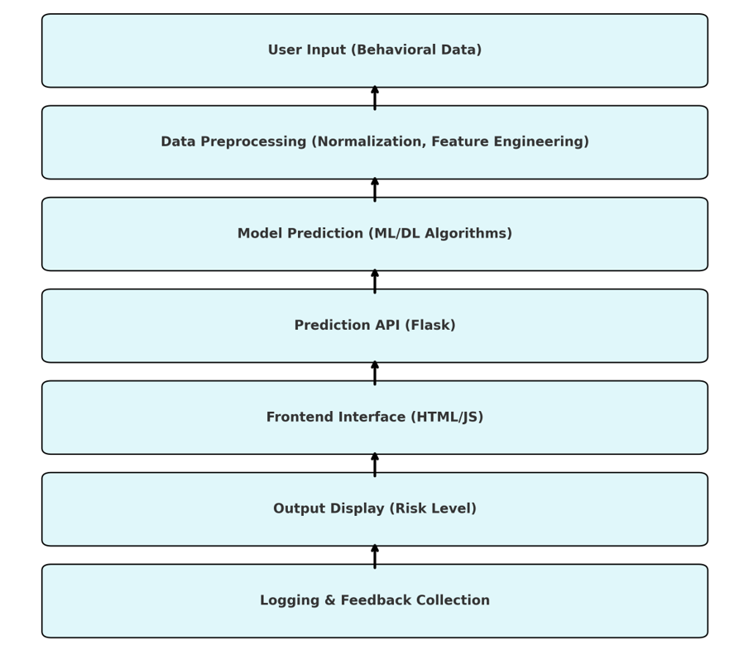

Algorithm
np.random.seed(19680801) # seed the random number generator. data = {'a': np.arange(50),
'c': np.random.randint(0, 50, 50),
'd': np.random.randn(50)
}

data['b'] = data['a'] + 10 * np.random.randn(50)
data['d'] = np.abs(data['d']) * 100
fig, ax = plt.subplots(figsize=(5, 2.7), layout='constrained') ax.scatter('a', 'b', c='c', s='d', data=data)
ax.set_xlabel('entry a') ax.set_ylabel('entry b')

Sample Outputs
Exploratory Data Analysis (EDA) 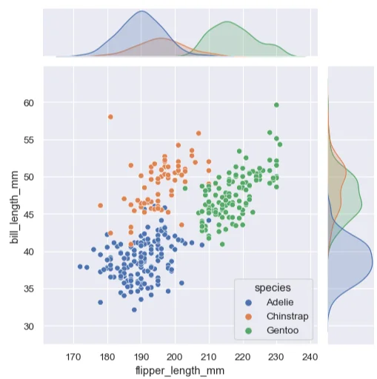

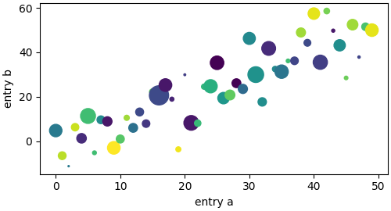

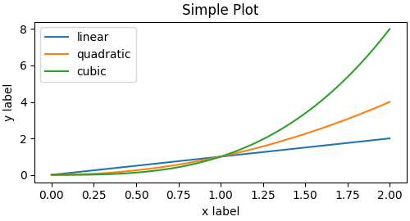
Object Oriented Interface

Outcome of the Training

The six-month internship at Active Galaxy Group of Companies was a transformative learning experience that blended academic knowledge with real-world implementation. Working on the project titled “Public Human Assault Prediction using AI,” I gained extensive exposure to full-cycle AI development—from data preprocessing and modeling to deployment and ethical evaluation.Acquired strong proficiency in Python for scripting AI workflows.Gained hands-on experience with Pandas, NumPy, Matplotlib, and Seaborn for data analysis and visualization.
Implemented and compared various machine learning algorithms (Logistic Regression, Decision Trees, SVM).Developed deep learning models using TensorFlow/Keras, including architecture design, tuning, and evaluation.Deployed AI models using Flask, and created RESTful APIs for real-time inference.Built responsive frontend interfaces with HTML, CSS, and JavaScript to integrate AI services with user input systems.
Designed and optimized a prediction system to classify human behavior in public settings.Tackled challenges such as imbalanced datasets, model overfitting, and latency in inference.Integrated error handling, logging, and real-time feedback mechanisms to improve system reliability.Developed a scalable architecture with modular components that can be extended in future deployments
Practiced responsible AI development by using anonymized datasets and bias mitigation strategies.Studied global standards (IEEE, UNESCO) on ethical AI, applying them in data processing and model evaluation.Implemented fairness and transparency by documenting model assumptions and limitations.
Gained initial experience in system deployment using local servers and Flask.Configured and tested RESTful APIs for prediction pipelines.Monitored performance metrics, model confidence scores, and user interaction logs to assess real-time usability.
This internship gave me the confidence and skillset to work independently on AI-based solutions. It bridged the gap between classroom learning and practical application, and provided a strong foundation in:
The experience not only strengthened my technical portfolio but also shaped my mindset to become a responsible and innovative contributor in the evolving field of artificial intelligence.
Conclusion

The internship at Active Galaxy Group of Companies has been a pivotal milestone in both my academic and professional development. Over the course of six months, I had the opportunity to work on a socially impactful and technically demanding project titled “Public Human Assault Prediction using AI.” This initiative exposed me to the dynamic and multidisciplinary nature of artificial intelligence and allowed me to apply my classroom knowledge in a meaningful, real-world context.
From understanding domain-specific challenges in behavioral analysis to designing and deploying an intelligent, real-time predictive system, this internship has been rich in both scope and depth. I was actively involved in every phase of the project—ranging from data collection, preprocessing, machine learning and deep learning model development, to API integration, user interface design, and deployment testing. This experience allowed me to build a strong foundation in full-stack AI development and understand how to align technical solutions with real-world needs.
Beyond technical skills, I also cultivated an awareness of ethical AI practices, particularly concerning data privacy, bias mitigation, and responsible model deployment. By working within a team-oriented, research-focused environment, I learned the importance of collaboration, iterative development, and communication with both technical mentors and end users.
Additionally, preparing documentation, conducting live demonstrations, and responding to feedback helped me refine my ability to present complex solutions clearly and confidently—skills that are crucial for future roles in the industry.
In conclusion, this internship was not only a chance to improve my coding and AI proficiency but also a formative experience that reinforced my passion for solving real-world problems through technology. I now feel more confident, capable, and ready to contribute to industry-level AI projects and continue my journey as a software and AI engineer..

